STORYBOARD
Module 2: Clinical Documentation – Lesson 2.1: Patient Records
Scrolling / heading-based format (Rise 360)
Prepared for
Meridian Health Partners
Prepared by
Zach Dornisch, M.S. IDT
Learning & Development
March 2026
Version 1.1

Lesson Overview
Course | MeridianChart EHR Training Program
Module | Module 2: Clinical Documentation
Lesson | Lesson 2.1: Patient Records
Target Audience | Physicians, Nurses, Medical Assistants
Estimated Duration | 30 minutes
Lesson Objectives | Open and navigate a patient record using two search methods; identify the key chart sections; locate recent notes, orders, and lab results
Authoring Tool | Rise 360
Version | 1.1

For reviewers: read top to bottom — this follows the order learners scroll. Check the content is accurate and the flow makes sense; layout and responsiveness are handled by Rise. Add notes in the “Reviewer comment” line of any section.

Lesson Flow

Welcome
Welcome to Patient Records. In this lesson, you’ll learn how to find, open, and navigate a patient’s chart in MeridianChart — the foundation for everything else you’ll do in the system. You’ll work with a real example, Maria Torres, throughout.
↳ Format: Text
↳ Reviewer comment:

Why this matters
Every clinical task starts with the right chart open. Pulling up the wrong record, or taking too long to find the right one, slows care and creates safety risk. MeridianChart gives you three fast ways to get to a patient — and once you’re in the chart, a consistent layout so you always know where to look.
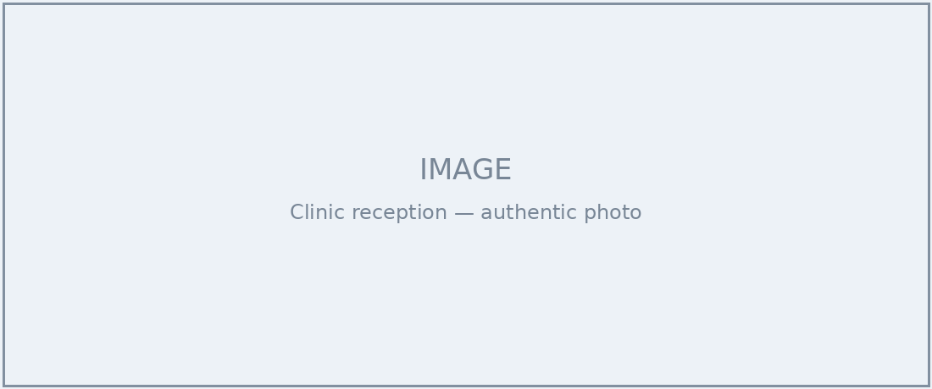
Authentic clinic reception photo — diverse staff and patients. Alt text: clinician greeting a patient at check-in.
↳ Format: Image + text
↳ Reviewer comment: Confirm photo reflects our clinic environment. — Dr. Santos

Finding a patient
There are three ways to find a patient in MeridianChart. Use whichever is fastest for the situation:
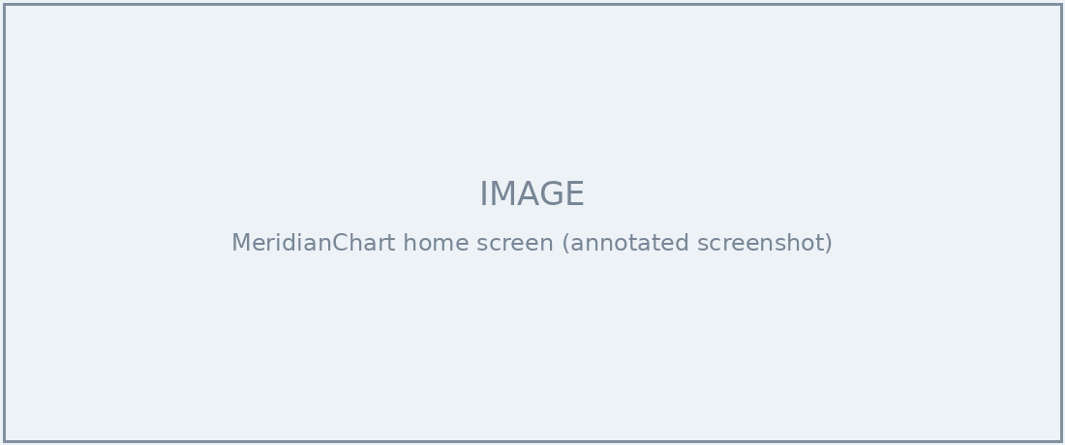
Home screen with the global search bar highlighted and three search methods numbered.
- Global search — type a name or MRN in the bar at the top of any screen; results appear instantly.
- Advanced search — add filters like date of birth, insurance ID, or clinic location.
- Recent patients — pick from the last 10 charts you opened.
↳ Format: Accordion (one panel per method) + image · Interaction: Learner expands each of the three panels to see a short demo · Narration: None — text-based
↳ Reviewer comment: Confirm partial-MRN search works. — Dr. Santos

Inside the patient chart
Once you open a record, you land on the chart summary. The left navigation panel holds the seven sections you’ll use most:
- Demographics — name, DOB, contact, insurance
- Encounters — past and scheduled visits
- Clinical Notes — physician and nurse documentation
- Orders — labs, imaging, referrals, prescriptions
- Lab Results — values with dates and reference ranges
- Medications and Allergies — current meds and flagged allergies
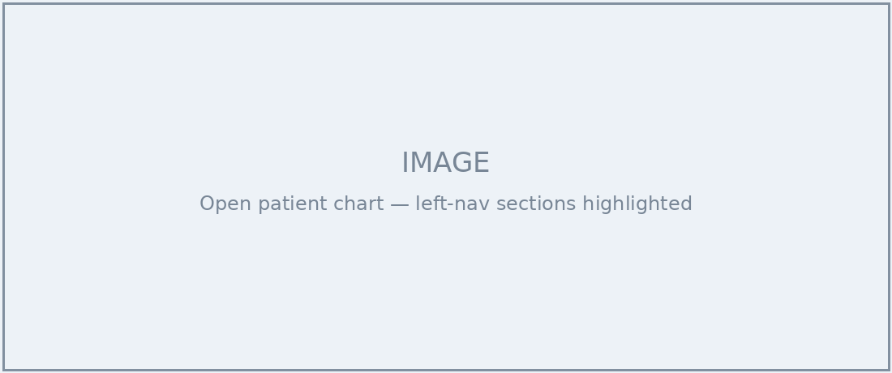
Open chart (Maria Torres) with the seven left-nav sections called out.
↳ Format: Image + text + list · Interaction: Hover each left-nav item to preview what it contains
↳ Reviewer comment: Order of sections matches the live build — looks right. — J. Whitfield

Try it: which section?
A patient calls to ask about their most recent lab results. Which section of the chart do you open first?
- A) Encounters
- B) Clinical Notes
- C) Lab Results
- D) Medications
↳ Correct answer: C — Lab Results. Feedback: “That’s right — Lab Results shows the most recent values with dates and reference ranges.”
↳ Format: Knowledge check (multiple choice, 1 retry)
↳ Reviewer comment:

Summary and job aid
Nice work. You can now find a patient three ways, open their chart, and locate the sections you’ll use most. Download the Patient Records quick reference to keep at your workstation.
↳ Format: Text + button · Interaction: “Download quick reference” button links to the 2-page PDF job aid
↳ Reviewer comment:

Content Review Sign-Off
By signing below, reviewers confirm the content and flow are accurate and appropriate, and approve this storyboard to proceed to development.
Name | Content Area | Signature | Date
Dr. Maria Santos | Clinical
James Whitfield | IT / system

